M2: Assignment – Windows Command Lane Dorscher
The Code
@@ECHO OFF
systeminfo | findstr /B /C:"OS Name" /C:"OS Version"
systeminfo | findstr /C:"System Type"
systeminfo | findstr /C:"System Manufacturer" /C:"System Model"
systeminfo | findstr /C:"Processor(s)"
systeminfo | findstr /C:"Total Physical Memory"
wmic cpu get name
wmic path win32_videocontroller get name

wmic memorychip get capacity
wmic diskdrive get name, model, size
pause

The Results
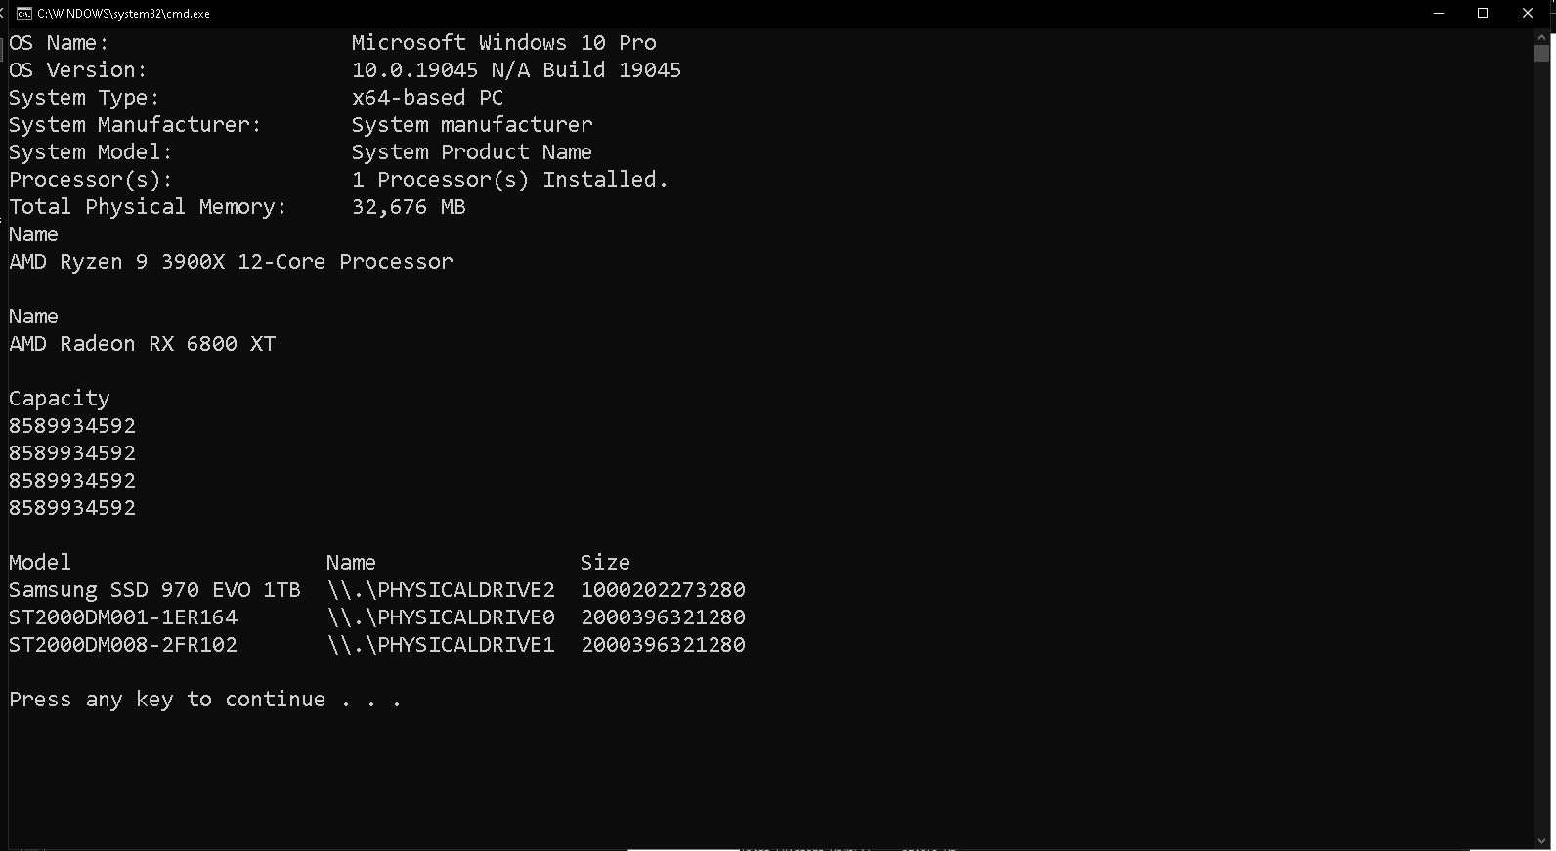

One of my biggest observations was how useful the systeminfo and wmic commands were in generating a detailed view of my system’s specifications. When paired with findstr, these commands became much more powerful because they allowed me to filter the raw information into just the details I wanted displayed. Without this filtering, the output would have been cluttered with unnecessary lines, making it harder to identify the most important information. Using the batch file, I was able to see my operating system, processor details, system model, video controller, and memory all presented in the terminal window. It felt like a lightweight alternative to opening multiple Windows UI programs, such as the Task Manager or the System Properties window, to gather the same data.
When executed, the batch file successfully displayed all of the requested information. This outcome confirmed that I had used the correct syntax and commands from the start. Because of that, I did not have to spend time troubleshooting or debugging the program. If errors had occurred, my plan would have been to carefully look at the error messages in the command window, since they usually point to either a syntax issue or a missing keyword. Another method I would have used to debug is running each command individually in a Command Prompt session to verify the expected results. Breaking it down this way would have helped me isolate whether the problem was with the command itself or the string passed to filter the output.
My last real experience with batch commands was back in a high school computer course. At the time, I experimented with creating a “fake virus” batch file that repeatedly opened windows with a matrix-themed scrolling display. It was harmless, but it gave me a first glimpse into how batch files could automate processes and even mimic complex behaviors with just a few lines of code. This current project reminded me of that experience, only now I see batch files less as a playful trick and more as a practical tool that has real uses in professional settings.
Although I have not worked with batch scripting much in recent years, this assignment reminded me how practical it can be. Simple scripts like this can automate repetitive tasks or pull system information instantly without opening multiple menus. Going forward, I look forward to learning more about the best use cases for batch programs and how they can be integrated into real-world scenarios. Overall, this experience reinforced the value of understanding fundamental tools, since even small scripts can have a big impact on efficiency.

Livewire. 2025. Master Every Command Prompt Command: Comprehensive Windows Guide. Retrieved from https://www.lifewire.com/list-of-command-prompt-commands-4092302

